Logo School
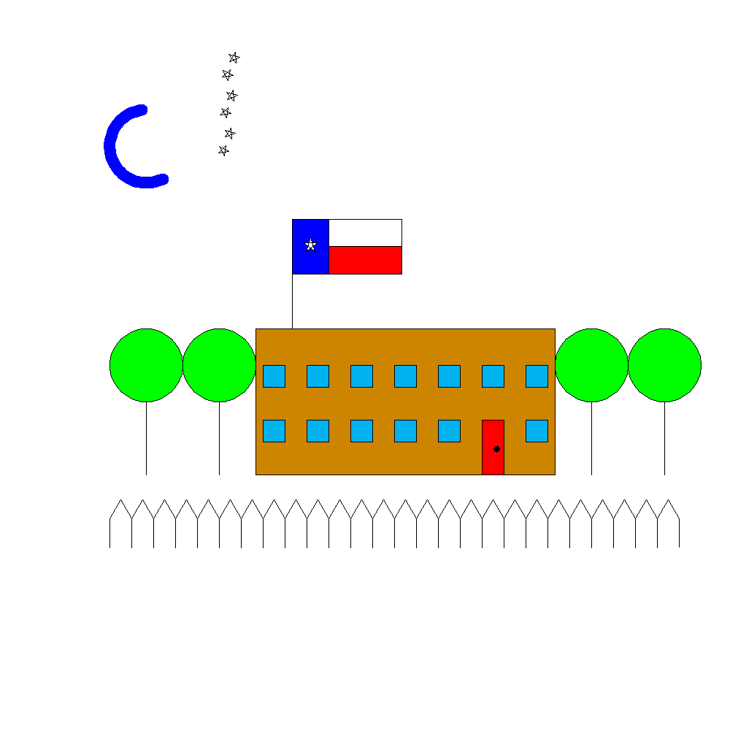
to school

building
topwindows
bottomwindows
picketfence
trees
flag
stars
moon

end

